Date: July 1, 1956 – Sunday
Place: From Paris to London
Weather: Cloudy, rain – Fair

Upon arising, I found the room in a complete mess. Sue ran in to inform me that there was no bread for breakfast so out I ran for some. Finally we lugged our two Melia bags, cameras, hats, cosmetic cases, pocket books and us down to the street corner to find a taxi to Melia in Arrondissement de l’Opera. We, of course, arrived a half hour late at 9:00 a.m.. Waving goodbye, the 60+ suitcases stacked atop the bus, we drove to Gare St. Lazare and got a train to Dieppe. After filing on the boat like cows we set out for Newhaven. We finally ate lunch, played bridge in the dining room – away from the poor suffering seasick people. I was quite happy.
A train got us, all 37 of us, to London by 7 p.m. Dinner was eaten at the Hotel Rubens, followed by a jaunt around Buckingham Palace with Skippy Meeker, Libby-Lee Stearns and Judy Moore. We got a big kick out of the guards In front of the gates, stamping their heavy feet three times as they turned suddenly about, swaying as they walked, balancing their long guns on their wide shoulders. How we laughed when a low whistle came from one of them. Their furry hats must be difficult to carry but they look good anyway.
After a nice warm bath, bed took up my main interest. I don’t remember too much after that.

Date: July 2, 1956 – Monday
Place: London – Hotel Rubens w. Grier Smith
Weather: Fair – rain

Breakfast English style tasted divinely good after 3 ½ months of bread and butter. The bus called for us at 9:30 a.m. and we set out to see London in a day. We drove along the main shopping streets and out across London Bridge which really isn’t falling down at all. We crossed the Themes again via the Tower Bridge that is so pretty. First stop was London Tower and in to see the Crown Jewels. Unbelievable and glistening they sit before your eyes: Crowns scepters, saltcellars, swords, etc., all studded with real and beautiful stones. How I kept my finger off my camera I’ll never know. Bloody Tower is recognized for its past prisoners, including Sir Walter Raleigh, although it is very plain.
St. Paul’s Cathedral was very interesting. It was built in 1675 by Sir Christopher Wren. It is large but I didn’t find it too special except for the lovely ceilings and architecture. Driving by Scotland Yard, the Buildings of Parliament and “Big Ben” which was all surrounded by scaffolding, we stopped at Westminster Abbey, a wonderful church. There it is crowded and cluttered with all sorts of things and tombs. The Tomb of the Unknown Warrior is surrounded by Flanders poppies. So many are there: Isaac Newton, Charles P. Darwin (my old pal), Queen Eliz I and her Essex Ring, Mary Stuart Queen of Scotland, Kipling, Chaucer and Dickens. - All wonderful people. It was there I met a D. U. from Dartmouth, a friend of Bob Caldwell. Funny.
That night Skip Grier, and I saw “The Reluctant Debutante,” a darling satirical English Society play. --- Coffee --- Bed.

Date: July 3, 1956 – Tuesday
Place: London – Free day
Weather: Fair

Grabbing my camera, Grier and I ran up the street at 10:30 a.m. to witness the popular “Changing of the Guard.” I wrangled my way up to the front of the crowd and waited. Then came the drums, flutes, English flags, red coats and black tall hats – all swaying together. In they went to the courtyard within the tall gates. We couldn’t get too near the fence because of the outside guard on duty, busy wearing his straight uninterrupted path. Not too impressed except for the colors, the shouts and the proud, happy, neat Englishman. I at least got up nerve enough to sneak up to the fence and poke my camera in for a touristy shot.
After the many guards had been relieved, the band struck up, all in formation, and marched away again, leaving us well contented.
Grier, Skip and I got a bus to Marble Arch where we started shopping along Oxford Street that is lined with shops. Tired of waiting on Skip and Grier who were trying on shoes, I wandered on, turning down New Bond Street and its expensive shops, but on I went. I couldn’t bring myself to buy a $15 sale cashmere sweater set. Inspected gold charms in an expensive and fancy store, went back to other shops and finally bought a charm for my bracelet of a Palace Guard in his cute gold house – and he moves! After stopping for a spot of tea, I entered Simpson’s of Piccadilly and couldn’t get out without buying Craton and John beautiful V-necked lambs wool sweaters. I met some other Hollins gals and only watched while two of them purchased their fifth cashmere sweater. I braved the busy “Underground” to Victoria Station and got to the hotel in time for a good steak dinner and sundae for dessert.
Washing done and face clean, bed feels mighty jolly good!

Date: July 4, 1956 – Wednesday
Place: London – Stratford-on-Avon
Weather: Fair, Rain

The bus called bright and early at 9:15 p.m. and off we went to discover some bits of England. Our British guide took a fancy to airplanes and factories and thus wouldn’t let us miss them. How excited he got when we passed the London airport and some of London’s new factories! Further on, way up on a hill, we saw Windsor Castle, and then in Woodstock saw the Palace of the Duke of Marlborough. The scenery is lovely. The houses all have such gorgeous flower gardens in front. I loved the cute little sheep grazing everywhere, too.
We stopped for lunch in Stratford-on Avon and ate in the Shakespeare Hotel. The food was OK. Afterwards, Shakespeare’s birthplace was visited. Very simple and only significant because of him. On to Warwick Castle which I loved. It’s private and is well furnished and had a few priceless paintings of Holbein, Reubens, Van Dyck. I liked the views from the windows, the wood carved tables, chairs, etc. and the old beautiful piano and armored suits.
In the rain we came to Ann Hathaway’s Cottage that is charming outside but dark and heavy inside. The most interesting part was the scratched signatures on the window of the bedroom. We then returned to Stratford to eat dinner at the Memorial Theatre. Grier and I made a mad dash back to Willie’s house to buy a book of his sonnets. We didn’t even get lost. After dinner I had a drink and then went in with the rest to see an excellent performance of “Love’s Labor Lost.” Shakespeare is as Shakespeare should be.
Back to hotel in London – Yawn!

Date: July 5, 1956 – Thursday
Place: Brighton (Bedford Hotel)
Weather: Dark, windy, gsit

This morning, really tired, we set on our way to make a long tour of cheery England. We had a nice day and begin with and got lovely views of the green rolling country side. After going through Kent, past orchards, gardens and Maidstone, we stopped at Canterbury. I was thrilled to see this huge cathedral standing before my eyes. The mother Church of England, and the one immortalized so long ago by Mr. Chaucer.
Inside it isn’t as cluttered as Westminster Abbey nor as beautiful. All the stained glass windows were blown out during the war. A few of us were dying to stay for the evening service with the boy’s choir, organ, etc., but our “lovely” guide had to hurry – hurry – rush. Anyway, instead, we stole in back near the choir and past the place where Thomas a Becket was murdered and went into the beautiful cloisters.
After sadly waving goodbye, we came to Battle Abbey. I had imagined it to be very stupid, but found it quite fascinating. Our guide was excellent and described all the Battle of Hastings, October 14, 1066 between Harold and William the Conqueror, who built the old abbey for monks. Only the foundations are left of the chapel, but part of the “parlor” and wine cellars remain. Another part is now a girl’s school. I like it after all!
We pulled on and with much wind and blowing sea spray we pulled up to our hotel for the night situated across from the rough English Channel, a beach and amusement get-ups. I stayed in that night and washed my dirty hair.

Date: July 6, 1956 – Friday
Place: Salisbury (Red Lion Hotel)
Weather: Fair, sunny

Today wasn’t too exciting but very good. Early enough I grabbed my cosmetic case, pocketbook, camera, rain coat and sweater and joined the rest on the bus. We got our last look at the line of hotels and flowers along the sandy beach. We drove through Portsmouth where several girls were jumping in their seats as there were several Navy ships in there. We unfortunately didn’t stop until Southampton where we ate lunch in a fancy hotel – and us in dirty blouses and loafers!
Full to the brim again – we went on – on to Stonehenge, a place I had seen in history books. There I found that a pile of stones can be vitally interesting. A wonderful guide described thoroughly the stone circles of the New Stone Age (2,000 – 1600 B.C.) where , facing an outer stone and standing in the middle, one can see the sun-rise during the summer. It was probably a place of worship of the sun. Excavation was going on, making it seem even more exciting. It is probable the people of that time came from the Mediterranean and North Seas. They had to drag us away. We got to Salisbury for the night.
Before dinner, Ruth Townes and I walked up to the cathedral (1230) that appears beautifully balanced from the outside. Inside, Evening Prayer was in progress. After, we wandered. I loved it – gold gilded ornaments, fan vaulting in the cloisters and beautiful choir.
After dinner I talked with Judy Moore and at last got to bed.

Date: July 7, 1956 – Saturday
Place: to Bristol - Grand Hotel
Weather: Sunny, fair

This morning while driving along, we spotted white figures on the hills which were explained to us by the cockney guide as grass cut, leaving the white chalk showing – in designs representing different associations of WW I and WW II.
We stopped first at Wells Cathedral (1175) of Gothic style. I was quite impressed. I shall never forget the wonderful Renaissance clock (1325), round to represent the earth and the dials as the sun and moon moving about the earth. Above it and to the right sat the little man who struck the hour with his foot and hand. As we watched the clock celebrate 12 noon, just under the clock came four men on horseback, two going in the opposite direction than the other, and every other one got knocked back by the oncoming’s sword. – Clever as can be!
The architecture was different – almost modern with huge inverted arches leading to the choir and the sides. There is also the famous carved modern crucifix but no cross. I found it beautiful. I loved the clustered pillars, fan vaulting with the side chapels, and the cute carved tales at the top of the pillars – “Toothache” (medieval) being my favorite.
Sadly leaving, we went on to Cheddar for lunch and a tour through the rough caves where was found a prehistoric man. We found lovely limestone lit by different lights producing nice effects. The stalagmites grow one cubic inch in 4,000 years!
Before leaving, tried to send cheese home but couldn’t, so bought a little for me, Grier and Sue.
After driving 20 miles to Bristol, got the 2nd bus driver to take me back to get my lost camera!

Date: July 8, 1956 – Sunday
Place: Oxford
Weather: fair, sunny

After hearing so many church bells ringing, we got up somehow, ate and got aboard the bus to head for Oxford.
We drove through Bath which actually wasn’t as exciting as I thought maybe it would be. We ate lunch in Gloucester in a very quaint but not too clean restaurant. The court yard had pretty flowers. After playing with some woman’s baby, we left and stopped, after some disputed debate, at the “Little Village” in Bourton. Within was an adorable copy in miniature of the olde English town. Tiny, exquisite gardens, trees, plants, etc. Choir music from within the two churches, waterfalls and streams. In the cemetery was an even smaller duplicate of the miniature. It was such fun to wander and hover over stone roof tops.
At Oxford, our guide insisted that Christ’s College was most typical and that would be enough to see, so we stepped inside the courtyard, inspected the neat chapel or “cathedral” and then the dining hall lined with portraits of great men who had attended this old and famous college and university. I was a bit disappointed with it as we didn’t see much and what we saw wasn’t too special, although it did seem quite old and jam packed with ripe tradition. We weren’t allowed in any other buildings – Too bad!
At the hotel, I talked with Judy Moore and got nothing accomplished. – The usual me!
Met a man in the elevator, had a drink in his room with Grier. We learned about bull fights.

Date: July 9, 1956 – Monday
Place: London – Stratford Court Hotel
Weather: Cloudy and fair

To the windy roads of England! After a few bumps and grinds we caught sight of beautiful Windsor Castle sitting atop a hill. Before eating lunch we had the vicar of St. George’s Chapel show and explain what he could about it. He was a nice man and did his best. Built in 1475, aided by Edward III and Henry IV. On the ceiling are many seals of royalty, including the red and white roses of York and Lancaster. Laying side by side were wonderful tombs of white marble of George V and Queen Mary. I adored and admired the magnificent tomb of Charlotte, daughter of Charles IV, who married out of royalty and died at child birth. In the choir are all the assigned seats of knights, Order of the Garter, Dukes, etc., and of the sovereign. On the floor is the tomb of Henry the IIII.
After lunch we visited the State Apartments which contained lovely furniture, bowls, chandeliers, and paintings by Rubens, Holbein, Van Dyck (Chas.I). The tapestries of Goblin. St. George’s Hall for reception was hue and spacious, but the dining room took all with the mahogany table set and had seating for about 160 people. The skylight ceiling was decked with three of the most gorgeous chandeliers I’ve ever seen! We got to see the Queen’s (Mary) Doll House. – Fabulous! It has everything imaginable from linens, chandeliers, candles, itsy bitsy scissors, knives, letters, to baby crown jewels! Extra cases held the remaining parts.
Hampton Court was unimpressive except for the sunken gardens of Henry VIII and the rooted vine (1768) which took up a whole green house. I saw the Montagna cartoons of “Triumph of Caesar” but couldn’t keep in post with Mr. Ballator. Busky Park was lovely but couldn’t stop to admire the many ducks and fauns.
Went window shopping with Grier on Regent Street.

Date: July 10, 1956 – Tuesday
Place: London – free day
Weather: fair – warm

Free at last! Of course a free day can’t be spent in relaxation. The feeling that something might be missed constantly creeps in and haunts you until you find yourself out again tramping the streets. So out I went – all by my lonesome as the others were either buying in large groups (which I cannot do) or heading for art galleries, Parliament or other such museums. I wandered leisurely but wide-eyed up Oxford Street – battled the traffic and down on Old Bond Street. My eye was caught by Mr. Benson and Hedges so went in to “look.” The smell of wood and fine tobacco still remains with me. – Umm – After many explanations, etc., I walked out with an OK pipe for Craton and a box of matches with Big Ben represented on top. I stopped by “Simpson’s” to pick up my umbrella left there the last time I’d been in London. In Burlington Arcade I et Bette Van Deventer and Linda Vaughn who directed me to the Wax Museum. First, before taking the tube, I admired and snapped a picture of “Eros” God of Love at Piccadilly Circus. The Wax Museum was wonderful! Me. Taussaud worked on heads from the guillotine during the French Revolution and her work is continued. I liked the Royal Family, the American presidents, sports people, world leaders, Jeanne d’Arc, the historical scenes, etc., but couldn’t get nerve to enter the “Hall of Horrors” so came back to the hotel for dinner.
Grier and I went to the play “Hotel Paridiso” with Alec Guinness and found it to be very cute and funny. We took a taxi back and had a “Pims” in a nearby pub. That was good, too.

Date: July 11, 1956 – Wednesday
Place: to Oslo - Hotel Viking
Weather: fair – sunny - cool

We left the hotel in London by 9 a.m. and drove to the huge London Airport. This thrilled Mr. Jackson, our guide. How he loves airplanes! After Customs, changing of what money we had and being sadly tempted by cashmere sweaters, we safely boarded a 4-engine plane! I lost my bet on 2 engines) and soon we were in the air. – What a divine feeling! I was next to the window but also to the wing, but could see out OK. From the air we saw the last bit of jolly olde England and the blue North Sea. We flew over land again while later, presumably, Denmark and made a stop at a tiny airport in Sweden, very close to the water. It scared me out of my wits.
Pretty soon we had to leave the ice plane as we were in Oslo, unbelievably true! The sight of so many pine trees and good fresh air was divine. And the sun was nice and warm!
My first impression of the hotel was the prevalent smell of fish. Wow! (They say it was because of the soap!) Before dinner Sue and I braved the streets, looking in shops and seeing how inexpensive silver was. I adore the jewelry and was dying for a ski sweater. All of a sudden it rained rather hard but after standing five minutes in a doorway it stopped. – Odd.
After dinner, Grier met some boys in the lobby and got me, Sue, Dotty, and Skip Meeker dates. All but one of the boys were Norwegian but all spoke good English. We took taxis up a hill and saw the beautiful 60 meter ski jump. At a chalet-like place we had beer and white sweet wine together and learned how to skol. We looked at Oslo through a telescope. I was amazed that at 9:30 p.m. it seemed like 6:30! Time to go home but no taxis. We ran up a windy rocky path and just caught the ski train into Oslo. My poor date. He was a battle – such red eyes! I dragged him to the hotel and after tugging my squeezed hand free, was able to get in the hotel and up to bed.

July 12, 1956 – Thursday
Place: Oslo - Hotel Viking
Weather: Sunny – warm

Today was Tour Day. So, like all good tourists, we packed our sun glasses, pocketbooks, notebooks and cameras on our backs and were off. We learned much about the pretty city founded in 1050. After passing the statue of their famous poet Ibsen, we came and went in the new and modern City Hall, built between 1931 and 1950, costing $5 million.
The astronomical clock, the largest of Europe is lovely. It even shows the eclipses of the sun and moon. Inside there are many murals in modern frescos. I liked best “the Boy Entering the City” and the frightening one of the “Occupation by Germany in Norway During WWI.” Hate is plainly depicted in each scene – something we Americans have yet to really know! – There are scenes of their hero Herald who was killed in England in 1066. He was a Viking King and always is on a horse. The constitution murals and those of the “Four Seasons” were lovely – The snow, wind, rain and sun could almost be felt. Winter must be wonderful here. Skiing, too. Murals, tapestries, pine, shiny marble all went into this proud building. How mad I got at Mr. Ballator taking it apart technically with regard to art. I think he missed the point completely! Oh, well.

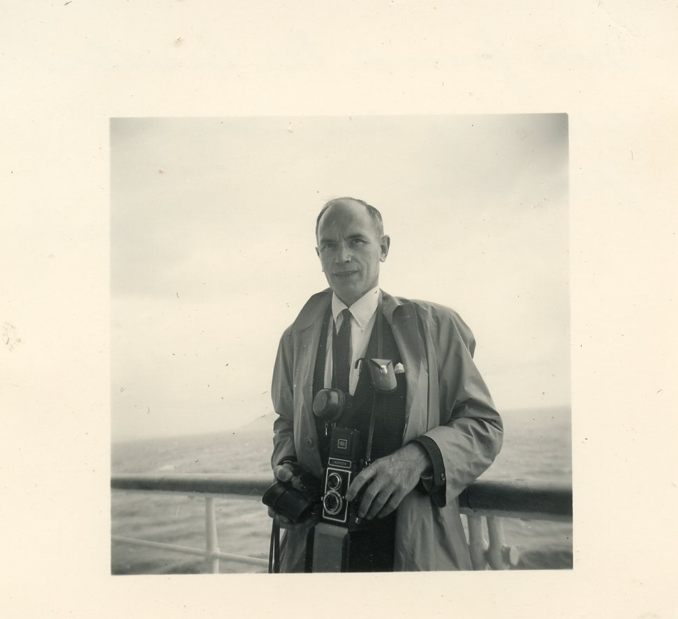

Mr. Ballator

We next strolled through Frogner Park (we didn’t stop to go in the Palace of the King) It was very modern with shaped wrought iron gates, gardens, huge swimming pool, green grass, many statues and fountains. One huge fountain surrounded by men and women statues carried the theme of the Cycle of Life while further up was an odd shaped obelisk carrying the theme again. It was different and refreshing. I liked it.
We then had lunch at a fancy restaurant with music, “Frascati. Well filled, we climbed the hill and saw the ski jump but didn’t get to see the ski museum (Maybe another time) We saw the “Kon Tiki” and stood amazed that that insignificant collection of wood could possibly have crossed the ocean! After that, we saw the “Fram” – a polar ship of Nansea and Archer which has been the furthest north and south than any other. Inside it was awfully musty, but the equipment was interesting. I liked the Viking ships, some used as burial places for kings. Three of them made of oak dated back to 800 A.D. The open air and the wandering Folk Museum displaying old Norwegian houses was fun. I loved the rot back house and wooden church that were very quaint and cute.
Dinner, scotch, with Grier and Sue. Bed.

Date: July 13, 1956 – Friday
Place: Oslo – Viking Hotel
Weather: fair – clear – sunny

Being superstitious is one thing I never believed in, but I’m beginning to think more about it now. Early in the day, I had haphazardly remarked on this being an unlucky day. No wood happened to be near at hand, unluckily. It all started as usual.
After breakfast, I gathered up my “pack” of traveler’s cheques, and Lamar Goodykoontz and I started out shopping. The jewelry stores are a downfall with such beautiful pins, earrings, necklaces, etc. that I couldn’t resist. In the next store we met Mimi Hay and Peg Crowther who helped me pick out my gold charm of a fish - truly representative of our complete surroundings. Everything smelled of it. We then went looking at sweaters and I happened to get caught by one which I couldn’t pass up. By that time we were hungry, so back to the hotel we went. Since I’d missed going on the boat ride with Sue and Skippy in the morning, I planned to meet Judy Moore, M.G. Galway and Lamar after I’d packed my suitcases. Rushing through that, there wasn’t too much time to spare to get the 3:00 p.m. boat. I didn’t find the girls. After leaving my small case and raincoat in a spare room because of checking out time, I ran down to the docks by myself and took a glorious boat ride among the green fjords and saw sailboat, quaint summer houses, ships, liners, and even the large white ship presented to King Hakon II on his 75th birthday. I nearly went wild with my camera. The blue sky and white clouds were perfect. The Italian man sitting next to me came back to the hotel on the tram with me. I then sat on the terrace to talk with some of the girls, went up to the extra room to change my shoes, leave my camera and get writing paper and went downstairs to write letters and then go to dinner. When it came time to leave for the train, I combed the room and could NOT find my camera anywhere and neither could any of the men of the hotel. Leaving my address and a plea, I boarded the “sleeper” in Oslo and soon was on my way to Stockholm. The view along the way was magnificent with hills, lakes, ski jumps and more green hills and pine trees backed by a deep blue dusky sky. Where was my camera?!!
I unhappily had to write pop the sad news and then tried to get a few winks of rocky sleep.

Date: July 14, 1956 – SATURDAY
Place: Stockholm – Malmon Hotel
Weather: Fair

I got up at the last possible minute. It still was dawn at 7:30 a.m. Finally at the hotel we had our first sparse continental breakfast since we’d left Paris. After I’d changed my money I ran right into Sybll Tyrrell and Donna Lasky from Hollins and Shreveport, Louisiana. There they were, big as life, but I had to rush off and be the last again on the bus.
We saw Fjallgatan, the port, and stopped to visit their Pantheon (1296), and a Lutheran church. There were many carved graves in the floor, scores of copper coats of arms and several nice side chapels with lovely wrought iron gates. Buried there are members of the dynasty, Gustave III, Desideria (“Desiree”) and Bernadotte – King in 1818.
We drove by the Royal Palace, Stock Exchange, Swedish Academy of Literature. We walked down a narrow old street into a darling little courtyard and garden of the 16th Century. Passing the Free German Church, we visited the amazingly huge and well equipped Southside Hospital (1937-55). It can hold 1,400 patients, has 120 doctors, with 19 poly clinics . Underneath it is an air-raid shelter and another hospital for 3,000. All this under socialized medicine!
Beginning to get hungry again, we had to first visit the City Hall (1911-23). The main things I remember about it are the elm and birch tables beautifully polished and made with designs from different kinds of wood fitted in. The modern architecture reflected Eastern influence, especially in one large room. The walls and ceilings had golden mosaic designs. In the long reception room were a series of beautiful black marble columns and chandeliers. The main huge hall had a lovely staircase and held a large grand organ with 10,000 pipes. The main parties of Sweden are the Communist, Conservative, Liberal and Social-Democrat.
Lunch at last was had in a very nice part of town in a wonderful restaurant Sollsden. I thought the smorgasbord would never end, and then came the steak! Tummies full, we went to see Drottingham Palace’s Theatre of 1760. It was not too interesting except for the old stage, sets, and candles lined up on ropes for light. The Palace was long and became tedious as we grew more and more tired. Some paintings were good but the decoration was terrible – ornate but no color schemes.
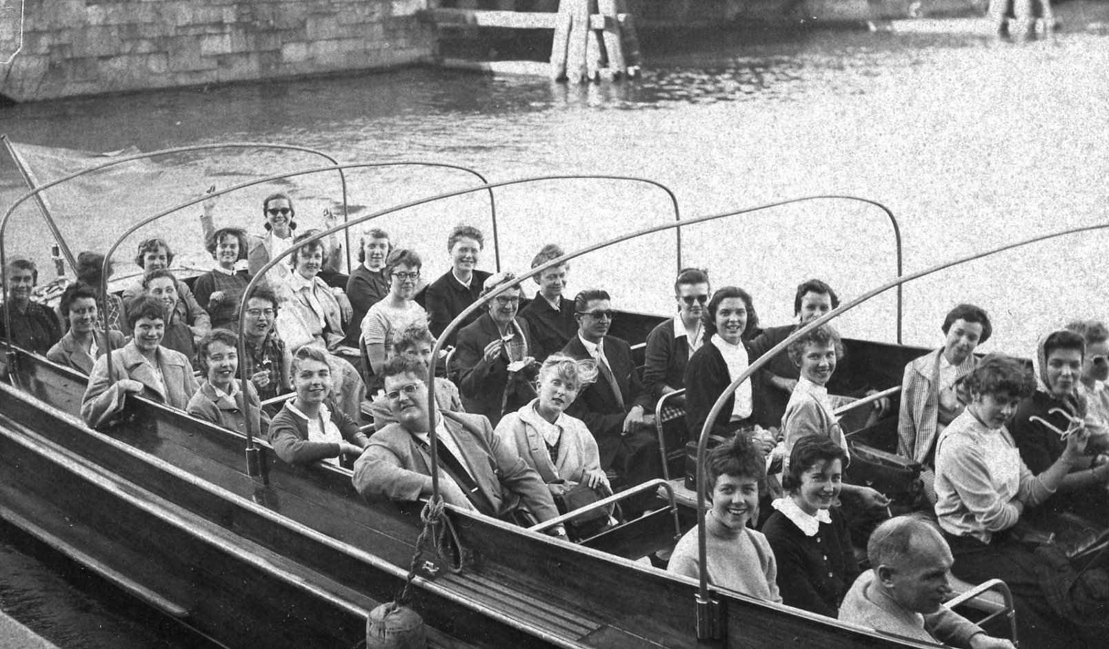

We then went on a boat ride up a river of the Baltic Sea. The day was lovely but I was too tired to really appreciate it. Grier came to talk after dinner, but not for long.

Date: July 15, 1956 – Sunday
Place: Stockholm – Malmon Hotel
Weather: Sunny, warm and beautiful

Have you ever had a perfect day? Well, just about.
At 10:30 a.m., ready and excited, we all met in the lobby with shoes and bathing suits wrapped in stolen hotel towels in our arms. We walked to the station and took a train north up to Saltsjoduvnas where Mr. and Mrs. Lonegren and Sally (“Corky”) met us – all 32 of us! Ann Hedberg and I went in a smaller boat with six others. Mr. Lonegren led us way out to one of the many isles where the Lonegren’s had rented an adorable house for the summer. We were sitting on the dock in our bathing suits when the others arrived on a friend’s huge yacht. Diving and swimming off the boat was divine. The water wasn’t too cold once you got in. Just before lunch several neighboring boys came sailing up in three nice(!) Sailboats and stayed for lunch.
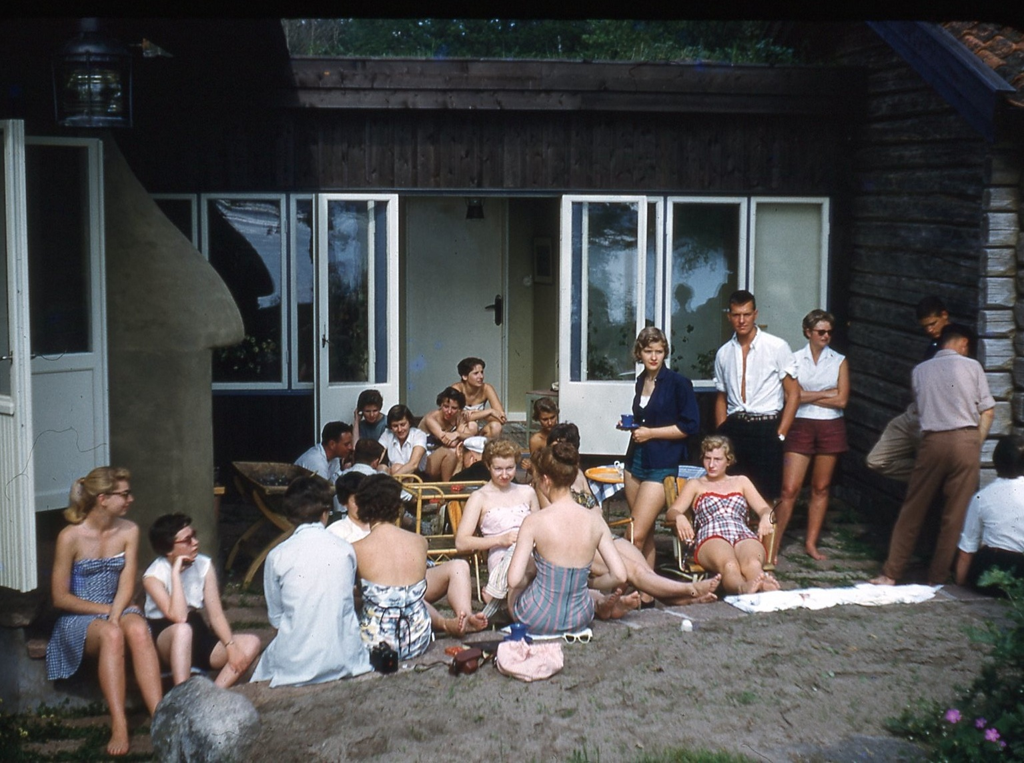
Afterwards they took some girls out sailing but I waited for the speed boats to go water-skiing!! My turn: I tried to get off from shore, but fell twice, but the third time I DID get up (yeah!) and had a fine time but soon fell, so did it again, getting better (ha!) and having lots of fun. I fell trying to jump the wake so swam back to shore. Puff, puff.
We changed clothes and went on the yacht back to the mainland again, then to the Hedberg’s for cocktails, dinner and dancing. While sipping gin and grapefruit juice, I met several Swedish boys and got a dance with a few of them. They showed us a good movie on the midnight sun in northern Sweden and some of their old customs – in color and sound, too!
Afterwards, more records were played and gaiety spread. The boys were amazed I’d never tasted a “Schnapps,” so I did. (Mr. Hedberg seemed worried, but I only tasted) Wow! Potent? Oh, no! - Only about 90% alcohol. Anyway, I did learn the customs of “skol-ing”
Come 11:30 p.m. we had to rush for the train. It was late, and while I was standing there, one of the boys came running after me to ask for a date then! Feeling good, I accepted. We drove back to the Hedberg’s to find his friends. They had all gone. We go back to the station where Mr. H. found us and told me I had to take the train. I did.
Back in the hotel, Grier, Sue and I had great fun talking in different accents to the boys who called up for me. (I’d accepted another boy, too – typical!) Finally we said we would only meet to say “good night.” We dragged Sue who didn’t even have shoes on, down to the lobby. Really funny! They, and several other (20) girls and boys talked us into going out so we did – after Sue got her shoes. We went to the only nightclub in town (unknown to police) and had tons of fun listening to the guitars and singers and drinking wine. One of the Negro men came in our separate room to sing and play for us. After we later climbed the dark, dusty and winding staircase, we found ourselves in an almost bright sunlight at 2:30 a.m.!
We drove through the town (only 10 of us) to one of the boy’s homes where one of the boys played piano, we had coffee, some wine, and danced and played records. It was very nice. I preferred dancing with the free boy until I heard he had a girl soon returning from the States. He was a jazz fiend, too. “Yeah, man!” By 5:30 a.m. we got back to the hotel, said our goodbyes, and finally got to bed. My date was very nice, blond and blue eyes. -- Nite, nite.

Date: July 16, 1956 – Monday
Place: To Copenhagen – Egmont Hotel
Weather: Sunny – warm

Sleepy as I was, I managed to get up, eat, and be ready to leave by 9 a.m. and catch the train from Stockholm to the tip of Sweden (Malmo). I tried to sleep on a stuffy train, jammed with people, 38 Hollins Abroaders, and 70 suitcases. Somehow I didn’t collapse, but even got some reading done. We were all a little tired but completely refreshed after such a day as we had. I ached from head to foot from skiing and swimming and had a sun-burned nose and completely straight hair from being too lazy to put it up (ha!). I was embarrassed to see the Lonegren’s and Hedberg’s at the station looking the way I did, and more so when they produced 36 Chinese Lilies for each of us. They sure are wonderful people!
Lunch was terrible on the train again. I ordered fish and was highly dissatisfied. Fortunately cute Libby-Lee Stearns was sitting with me who never eats much. She placed the fish in front of her and I ordered another meal of veal – such good meat. – Sure! We have it so rarely.
About 4 p.m. we reached Malmo and went on the boat to Denmark. How excited I was. Two hours later we swept into its busy, beautiful port. We drove to the hotel through the wonderful streets – with tears of excitement in our throats. On the way we passed a crowd standing in front of the lit up “Texas Bar” where a film was being made. We then went to the Tivoli Park for dinner in a cute colorfully lit up restaurant built like a Pagoda. For dessert they brought in ice cream with a divine sauce and American flags stuck on top – all stacked on a plate pyramid style with flaming torches. How delighted we were!
The Park was gay and cute but we didn’t stay. To bed.

Date: July 17th, 1956 – Tuesday
Place: Copenhagen – Egmont Hotel
Weather: Sunny, warm – wonderful

With great excitement we left right after breakfast to see the sparkling city of Copenhagen. We drove through some of its romantic, winding streets and fist stopped to see the Lutheran Memorial Church (1921-1942) – Very modern and quite cold – with its high arches and light stone. Hanging from the ceiling is a ship which is always in a church serving as a symbol for protection. We drove past the King’s Palace and Parliament, stopping on the way to record the cute long line of apartments each with different colored balconies, and also at the 800 year old fish market where we tried in vain to talk to a cute old man. We came to a series of clean white buildings and found they were the meat market – all so spic and span – everything is. We drove by all sorts of new and old buildings, hospitals, and the Stock Exchange (the oldest in Europe started by K. Christian IV). After browsing in the fruit stands lined up along a canal, we all took a wonderful boat ride down the canal in between the busy streets and cute colorful houses, then out into the dock area and ship basin. We went up almost to the northern tip of Denmark and got off where the mermaid sits on a rock – immortalized by the tales of Hans Christian Andersen. Near by, we stopped to admire the English Church and the lovely fountain beside it of four huge oxen working hard in the fields – the fine spray looked like hot wind from their nostrils. (1912).
Back in the bus, we went to the Queen’s Palace in time to witness part of the Changing of the Guard. It was funny, again, to see their different walk and march – almost kicking as they go. After lunch, we visited the Frederiksborg Castle of Christian IV. In one room were heroes of WW II, such as Anders Lassen (1920-45). Most of the rooms were richly decorated in Renaissance style with unbelievable delicately carved and hand done leather and wood or gilded walls and ceilings. The chapel was almost overly ornate with cherubs and blue skies on the ceilings, stained glass windows of English Renaissance style done by Imgo Jones. Very rich and breath taking. We could only walk along the upper balcony circling it. The altar was ornate but lovely with much gold and silver. Adjusting our eyes from that and of the what I called the “Mozart” ball room - also thickly ornate, we saw rooms with old tables, china and chests of ivory, mahogany and silver. Some of the clocks were delightful to watch as they struck the hour of 4. We drove to Hamlet’s Castle, Helsinger. We could only pass into the outside court. At the outer wall, standing by a stern guard, we could see the glistening shores of Sweden. After venturing down and funning, screaming out of a dark tunnel leading to I don’t know where, we started back to Copenhagen, stopping on the way for dinner. At the restaurant “Keysten’s Perle” the music was fine. Dessert was a production with carved pieces of ice and flares, three helpings of ice cream and whipped cream.
Saw a training ship gloriously in the channel – wonderful. – Home and to bed.

Date: July 18th 1956 – Wednesday
Place: Copenhagen – Egmont Hotel
Weather: Sunny and warm

Free day. Sleep at last! I laughed at first at the funny sofas converted into coffin-like beds with the strange guilt-like blanket, bit it did the trick. The hotel is remarkable with its very modern part being still built and is a dorm in the winter for Norwegian students. Telephones are in all the rooms. Great! Private shower and john for two adjoining rooms. After breakfast, at 10:30 a.m., I met Bette Van Deventer and we, plus four others, took a taxi into town to meet the rest for a delicious lunch - Much too much. Smorgasbord and yummy Danish pastry for dessert – Tuborg beer to go with. Being in a hurry, we, with Ann Gregory, ran through an art museum to please Mr. Ballator and because I wanted to see the Renoir paintings. Only few were there, though, but wonderful. We then finally found the department store “Den Permanent” so highly recommended by Mr. Fielding in his guide. Everything is there – expensive Georg Jensen, too. How I loved the $700 pin and $700 silver bowl. I bought a 75 cent ash tray and left. Wandering is fun. Bette and I got ourselves lost (not really) and both fell in love with Royal Danish china. I bought a beautiful blue vase and ash tray with a boat on it and also had to get a copy of my favorite, H. C. Andersen.
We stopped for an orange drink and amused ourselves by all the thousands of bicycles and few cars. In a tobacco store I ended up inspecting the women’s cigars, and got a bottle of good Cherry Herring for pop. I couldn’t find the gold charm I wanted so ordered it – of a mermaid on a rock. In the store I bought a pretty silver spoon for Craton and Joanie. Loaded up with packages, it was time to find the tram and get back to the hotel and dress for dinner.
We all dressed for our fancy night out for dinner at the “National Scala.” Impressed? Orchestra and stage show for us as we munched on our shrimp cocktail, ½ lobster and chicken - all so good. Ice cream with sauce for dessert. The acts weren’t too good, but oh, that music!
Afterwards, several of us ran across the street to Tivoli Park to join in with the fun there. We did! First came the roller coaster with many dark, dippy tunnels and curves; but how we loved it! I could only afford one ride. Then Skip, Dottie Meeker, Grier, Sue and I had silly pictures taken - me the mermaid, and Sue and Grier two sailors.
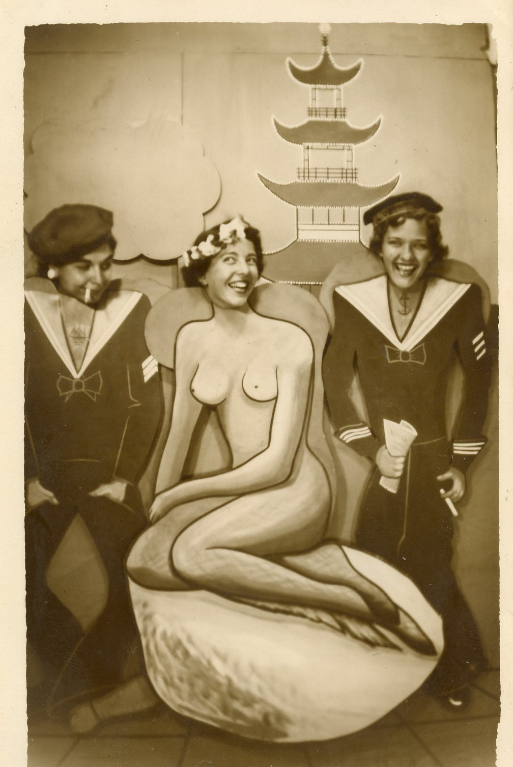

We then ran over to the scooter cars, but I watched, saying a few words to the English boy next to me. We watched the pretty fireworks glittering along with the gay lights and fountains. People listened to part of an outdoor classical concert but I had to leave – Leave the bubbling romantic clean fun of the Danish people of Copenhagen. I love it! We found the tram and swayed and bumped all the way back to the hotel so we could get o our “nighties,” wash our sleepy faces, clean our under things, and creep wistfully into bed – thinking carefully and remembering all the wonderful and precious things done in Copenhagen.

Date: July 19, 1956 – Thursday
Place: To Hamburg
Weather: Sunny, fair, warm

Early morning found us sadly embarking aboard the train to leave Copenhagen. We waved and silently vowed to someday return, and soon were sweeping past the beautiful countryside. Our time was spent reading Fielding’s Guide to Europe, reading, playing bridge, talking, or trying to rest our weary heads.
A few hours later we reached the tip of Denmark where we boarded a boat - train and all – for about three hours. We had a very good smorgasbord lunch on board and had fun watching the sea gulls circling above. How we laughed when one let you of you-know-what ad it landed smack on some man’s eye! Really funny! We soon had to get back on the train. As we went down the steps, roars of laughter arose from below as no one’s shirt would stay down because of the wind. We all laughed so hard we had to dry the tears.
Somehow our first impression of Germany seemed insecure – probably because of all the many tales from the war. My reading Escape from Germany didn’t help. The guards in the train station were wearing the same style hats seen in the newsreels during the war.
After finding again no mail in my mailbox, and wearily climbing up a few confusing back flights of stairs, I found my room with Sue. This time we pleasantly had a shower and john adjoining. After a long wait we ate and soon settled our weary limbs in the soft quilted bed.

Date: July 20 – Friday
Place: Hamburg, Ger. – Europiascher Hof
Weather: fair – some sun

Day came sooner than I had hoped but up we got, ate another continental breakfast and stood with the crowd of girls to scramble on the touring bus. The bus was terribly crowded with every seat put to good use – even collapsible one in the aisle. Our German guide was a rather good looking lad who turned out to be somewhat of a character with a long line of jokes. We learned the city was founded in 800 A.D., was Protestant, and mostly Social Democratic. We drove around the picturesque Aleter Lake, eyeing some of the cute sailboats (quite a luxury there), and stopped in the city proper to visit the Town Hall (1886-87) of the German Renaissance style. There, is the Council of Parliament, the members elected each four years. Across the inner court is the Stock Exchange that was hit by a bomb and is still in repair. The fountain in the center was nice. Inside were lovely ceilings of carved mahogany and walls of embossed leather. There was much brass grill work and marble – not too impressing but nice. Phyllis O’Brien added a little by getting stung by a bee. In the main Council Room is the large golden book of Hamburg – the Guest Book. The great reception room was impressive with the lovely crystal chandeliers and carved, gilded ceilings.
Back in the sunshine, we drove past many new buildings - the Houses of Court, the Bismark Monument - and then drove to the water’s edge. We ran down and jumped on a shaky sight-seeing open boat and whirred off after our picture was snapped. We went into “No Man’s Land” where ships from almost all over the world may come. Industry was overhanging in the mist of roar and smoke everywhere you look. We puttered up and down the great Elbe River. Looking right or left we saw hundreds of ships either in port from some foreign far off land, ships being repaired or made. The guide was quite proud of the largest floating crane in the world run by Diesel engines and can carry the baffling load of 10,000 tons. Our guide was amusing himself no end by cracking stupid jokes and making all sorts of funny noises – even at one point disappearing into the “head.” Tired as we were, we had to laugh.

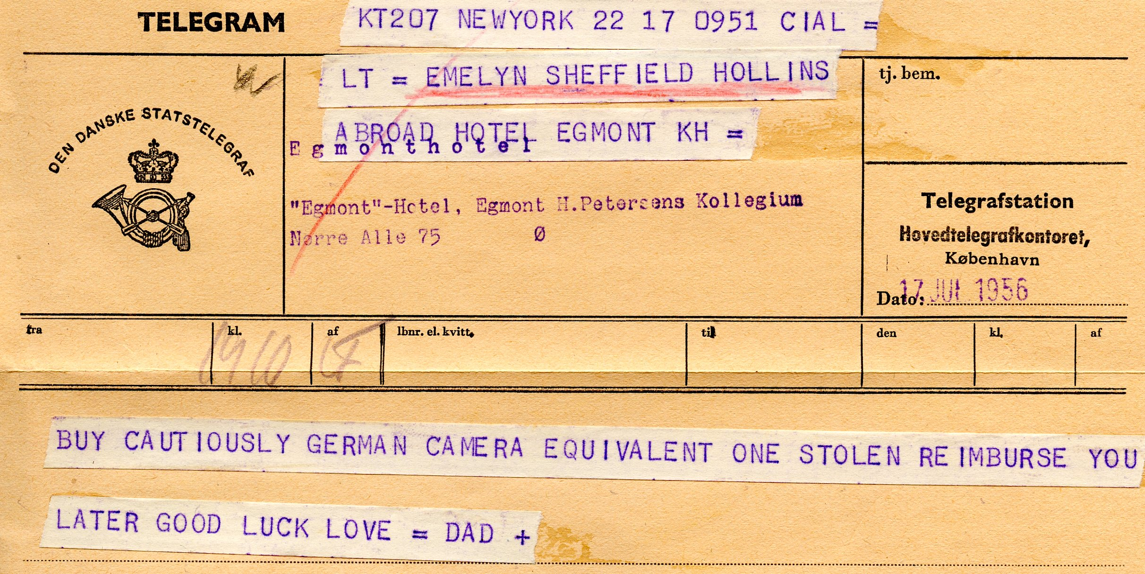
The trip soon over, we got back to the hotel in time for lunch. I grabbed Grier Smith and my traveller’s cheques and we headed out for the nearest camera shop. There I made the big purchase of a beautiful Zeiss Ikon Cortina IIa 2.8 for $59.00 – case included. Yipee! Happy at last, we skipped on down the street, but had to turn the eyes hard away from the wonderful toys, gleaming scissors, spoons, etc. After getting on and off the wrong tram, we finally got out to the Hamburg Zee (Tierpark) at 4:30 p.m. and first had a cool good beer for 14 cents and then ventured inside the gates, laughing at the monkeys, penguins, bears and sea lions. A mountain goat even ate a cigarette and bit of paper I offered him. How polite! 6:30 p.m. came too fast so we had to run to get back for dinner.
After talking with Skip and Dot Meeker, sleep came.

Date: July 21 – Saturday
Place: To Amsterdam – Victoria Hotel
Weather: Fair and sunny

Missing breakfast, Sue brought me two rolls with jelly to munch on while waiting for the delayed buses. Ah! We at last met up with our permanent Melia buses – the “Big” bus and the “Baby” bus – both dressed in blue, equipped with ice box, john and radio – very vital! The head guide was introduced as Mr. Vinagre, but soon became known as “Julian.” He was short, with black hair and mustache - very Spanish - and speaking better French than English.

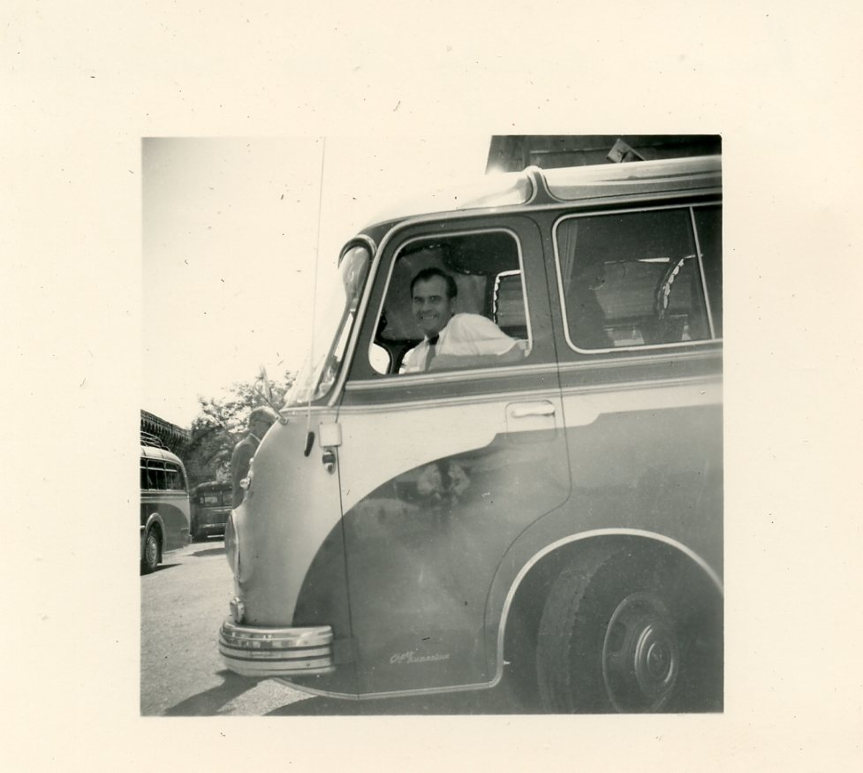
Julian in the Big Bus

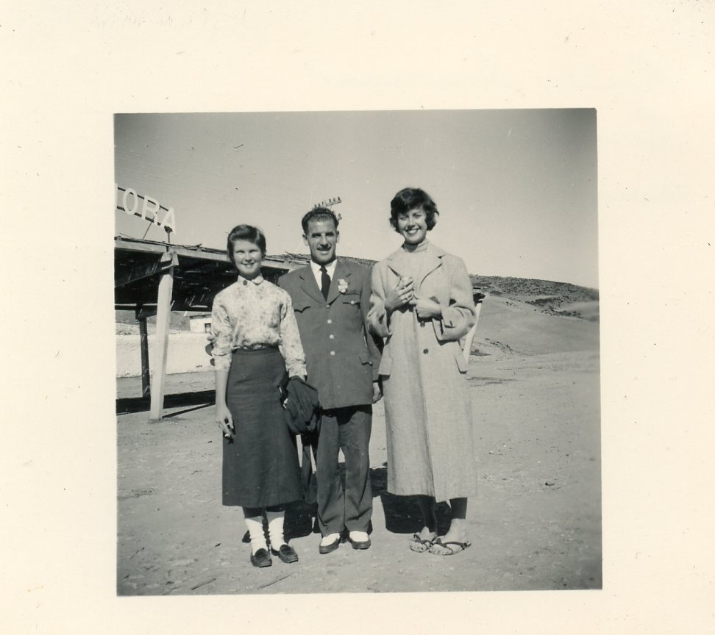
Juan with Ruth Townes and Mary Hateley

This day we drove unceremoniously through Bremen, stopping for a fair lunch in Lingen, and continuing on for almost all afternoon until we entered the Netherlands. The architecture took more of a quaint atmosphere than did the German. It was a long while before we spotted a windmill, but there it was, turning slowly with the wind, sitting in the green fields against the blue sky that was studded with billowy white clouds. Then suddenly we were there.
Here we were in the famous and wonderful center of Holland with its cobblestoned streets, windmills (that are fast disappearing), wooden shoes and romantic winding glimmering canals. Oh, how happy, how lucky I am! The hotel was very nice – shower, john, soft bed, good food and good service.
Early to bed is so hard to do, but tomorrow holds many new wonders and can’t be missed – Soooo . . .

Date: July 22 – Sunday (Judy Moore’s 21st birthday)
Place: Amsterdam – Victoria Hotel
Weather: Sunny, warm

How glad I was to have again such weather in order to see Amsterdam at her best. I was surprised by the guide who told us the city is an island built up on over 40,000 piles, and has some 80 canals covering about 80 miles. Upon driving around in the city I immediately became fascinated by the rows of old houses, each with its own façade and particular roofing. They faced the harbor that is busy with its ferry boats. Now stands the dramatic Tower of Tears, dating back to the 16th C. that served as a point of departure for the sailors who were leaving many loved ones on the tranquil shore. It is from this spot that Henry Hudson sailed to discover the great river and city of New York. His ship in miniature is on to of the tower as a weather vane. Down one of the canals are the sailors’ quarters – the oldest one dating from 1644. Canal Street somehow holds a spirit of excitement and seems to be so very down to earth. The old weighing station is now some museum, so naturally we didn’t stop there. In the Jewish Section the guide explained that the many houses that were torn down were demolished during the war by their own people for wood and heat.
Upon looking to the left or right, water in canals was almost always in sight, shaded by falling, graceful limbs and sparkling from the sun. On some waterways sit lines of cute snug little boat houses with their own flower gardens, porches and all! We drove through and stopped in Vondel Park that had beautiful flowers everywhere and monuments. I can imagine spring would bring blinding colors in every direction.
Just outside the city we found a windmill to take pictures of while battling the stream of treacherous bicycles. There seem to be very few mills left now which is too bad. We drove down by the most beautiful of all canals – the “Gentleman’s Canal,” past the Royal Palace (1648), and stopped to visit the art museum. We couldn’t battle the crowds to see the Rembrandt collection, but saw many others such as Frans Hals Ruisdael, (scenes), Leyster (portraits), Helst (groups with him and his wife in them), P. Potter (animals), Rembrandt (only a few – “Night Watch” – 1606-1668), Nil Maes (beautiful oil of a woman praying), Van Dyck, Rubens, etc. I liked it very much even with weary feet. I loved the Municipal Museum with quite a few sketches and oils of Van Gogh (1853-1890) – his self-portraits, trees, scenes, skies flaring in fury left me tingling. I didn’t even get caught taking a picture of a self-portrait. Ha!
After dinner at the nice hotel, we all ran across the street for a boat ride in the harbor, on the Amstel River and through some of the many canals. The harbor was OK – More boats and ships, . . . but the canals! At deep dusk, lights from the streets and buildings shimmered as we approached. On a few canals we strained to retain the sight of the line of lights along the length of the canals, outlining the bridges and even the houseboats. We even scraped the boat while going through the narrow bridges and would have to manoeuver to make turns. Two hours wasn’t long enough for me. I’ll never forget the cute old streetlights, narrow streets, bridges, lights, boat houses and all its wonder!
Slowly to sleep . . .
Date: 7/23/56 – Monday
Place: July 23, 1956 – Amsterdam – to The Hague
Weather: Fair, sunny

I must tell all about my free morning in Amsterdam. Grier Smith and I (instead of going to the Rembrandt Collection) went shopping and bought my gold charm (a windmill) and a big gorgeous china plate. Free, we wandered (with Skippy Meeker coming along, too) up and down streets along canals, snooping in antique shops and admiring the quaintness of our surroundings, not too sure of our whereabouts. We did find the old shop pointed out to us from the boat ride that looked out over the canal, but it was closed. I laughed to hear the pump up music vendor churning away on his large wheeled colorful cart. We HAD to walk through the narrowest street in Amsterdam, only three feet wide (Trompettersteig St.) and then hurry back for lunch. After that, I accompanied Grier while she searched in vain for a certain silver spoon – and at one point got enthralled with a little “Punch & Judy” show in the square with squealing children and darling puppets. It was getting late, so we hurried back to leave Amsterdam for The Hague.

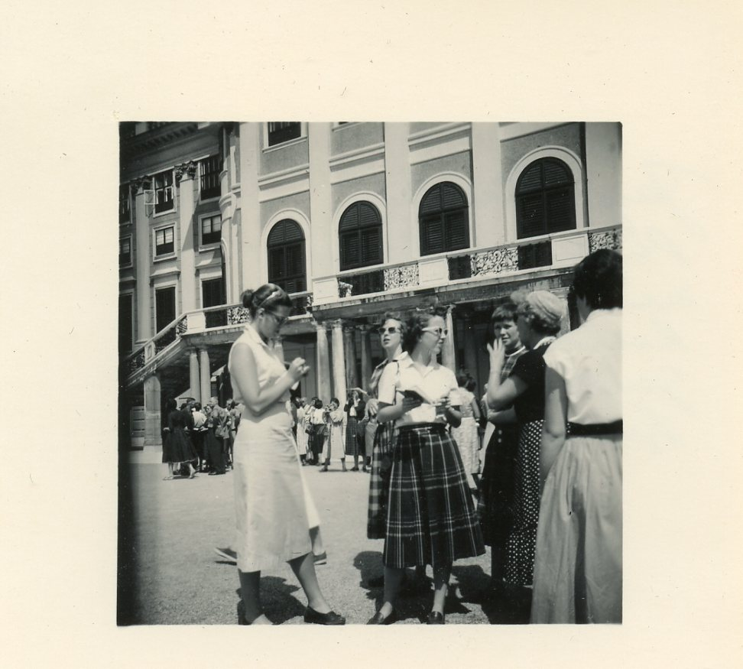

Gay Stanton, Phyllis O’Brian, Ruth Townes, me.

En route we stopped in Haarlem to look at St. Bavo Church and see the Municipal Picture Gallery with several paintings by Franz Hals. (Mr. B: “Not nearly as good as Rembrandt!”), but I like some portraits. His groups are too mixed up and confusing. Many are much alike. There, there was a cute dollhouse with 3,000 articles – what for? I don’t know.
In Leiden how I laughed as Mr. B. dragged a few of us to see the birthplace of Rembrandt. All we found was a running laundry and a placque on the wall! We didn’t stay in Schweningen as planned but slept in the Hague in a tiny and tall hotel – our room on a court.

Date: July 24, 1956 – Tuesday
Place: The Hague - Park Hotel
Weather: sunny- grey sky – windy

Squeezing a bit in the hotel room, I managed to get dressed and soon we were driving in circles, noses pressed against the window. We just made it under very narrow arches and only caught a quick view of Parliament, the Queen’s Palace and the rest of many various buildings. We visited the famous Palace of Peace (1907-13) which is the Permanent Court of Arbitration or International Court of Justice. The money for building it was donated by Andrew Carnegie and the material came from different countries. I was impressed by the intricate inlaid mosaic floor from India and also the ceremony of drawing back a curtain which brought out a huge vase of marble from Russia. – Ironical?
We drove through Schevenigen past the fishing docks and back for lunch. Bette Van Deventer and I decided not go swimming so started out to find the tram out to the fishing boats. She asked some women who, instead of indicating, insisted on driving us in her fancy German car. (She was from Switzerland.) She waited while we got out to snap pictures of the darling boats, wave goodbye to one along with anxious wives, and get pictures of men in bright yellow wooden shoes mending nets.
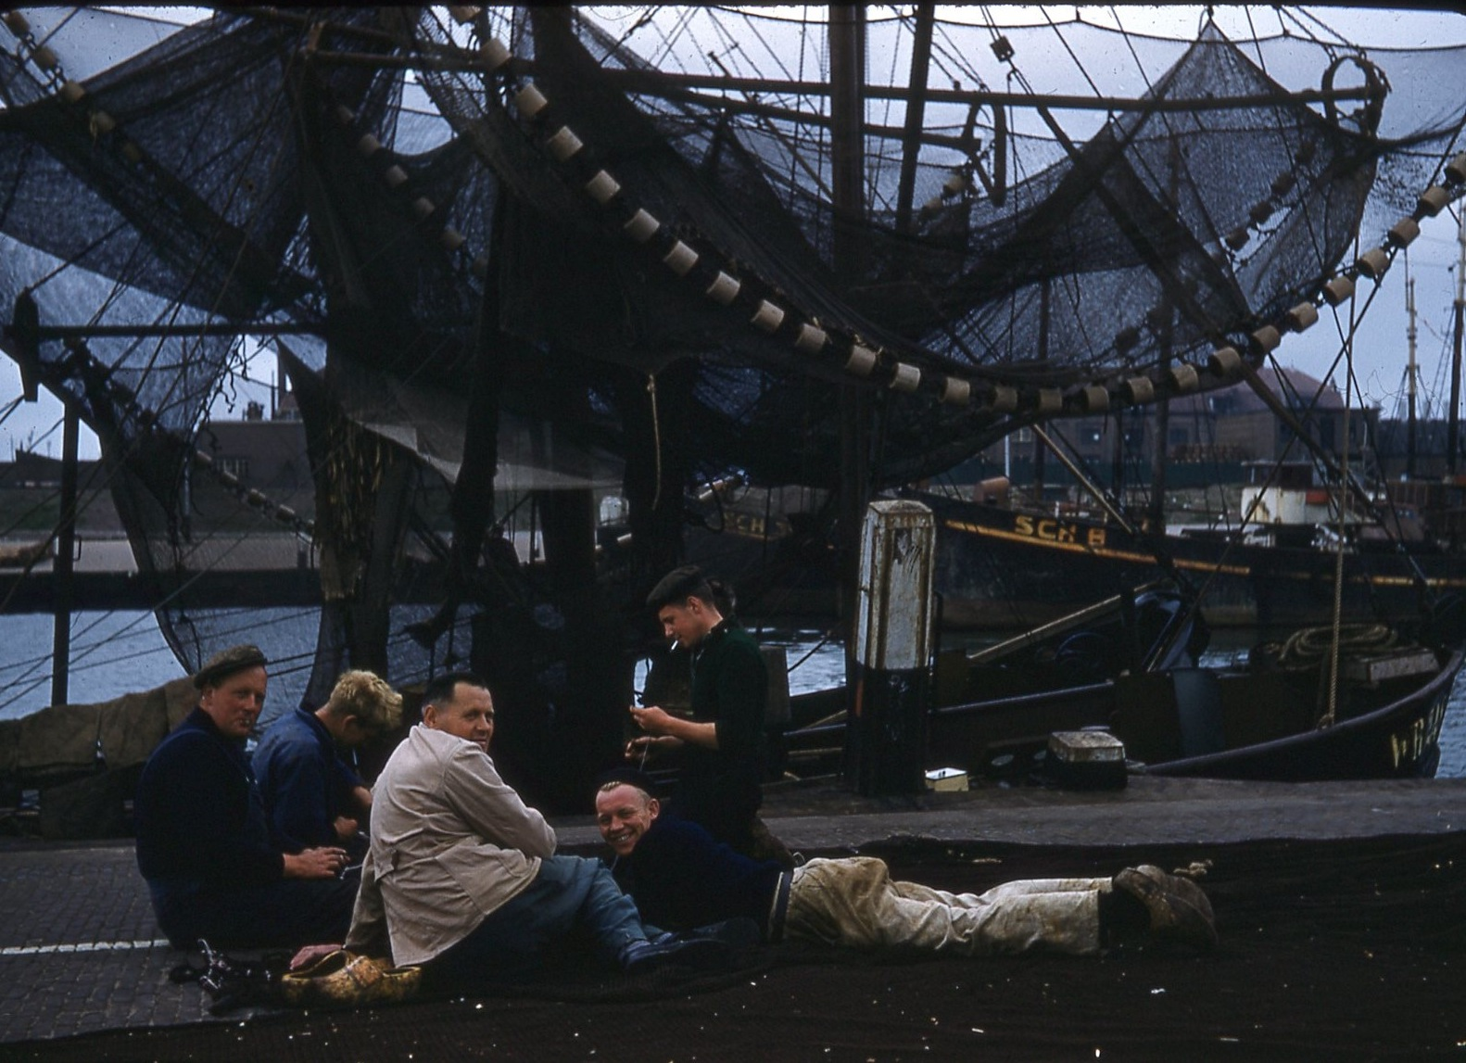

Back in The Hague, Bette and I sat in a café with hot chocolate and watched many Russian sailors go by. Then the buses drove up and they all gathered – almost sadly – never even glancing at us. Shortly before they left, one came up and asked in good English if he could have his picture taken with us. Fun. I made his friend use my camera too. Then another rushed up asking for my address. I did give it to him, but wrote no name – darn it. - Really an experience. They looked like monkeys with almost no hair.
Split a drink with Bette. - Bed.

Date: July 25, 1956 – Wednesday
Place: To Brussels – Splendid Hotel
Weather: Fair

Leaving not late from The Hague, we were once again on our way. I was not feeling too sad as The Hague, though clean and quaint, wasn’t too exciting except for the Russian sailors who left anyway – so – - -
We drove through the famous town of Delft and Rotterdam and into Belgium. In Antwerp we quickly glided through the cathedral there. Linda Vaughn and I were especially impressed by one of the side glass windows which as beautifully rich with flowing colors, far surpassing the others, aside from the many that had been destroyed. Where were several religious paintings by Rubens, a terrible overly ornate carved wooden pulpit situated near the real, a huge dome and a nice big organ. I liked it. Once again in the street, we found the buses and waited long enough for some to buy ice cream cones and pastry or others to snap photos of the beautiful square or fish market with gilded and glittering old buildings.
Then again past fields, brooks, and waving people as we sped past while many in the but were bent over books, magazines or knitting, or others in intellectual word-game conversation with Mr. Ballator.
Later in the afternoon we formed first impressions of Bruxelles. How good to see French again! The main street looks just like Broadway – flashing signs of Coca Cola and all.
Disappointment: the hotel! Our room was big but old with a strange layout. Food service was slow and the food not too good for hungry people. So what. We’re here!
Tomorrow we’ll see.

Date: July 26, 1056 – Thursday
Place: Brussels
Weather: Fair, sunny

Touring around the city in the morning we found much construction and activity. All this for the World’s Fair in 1958.
We saw the grave of the Unknown Soldier and went in St. Gudule (St. Michel) Cathedral constructed in pure Gothic style. There were several tapestries, not too many glass windows, and another very ornate musty smelling carved pulpit. It is nice but not too impressing. The market square and City Hall were of Flemish Baroque – trimmed with gilded gold. The Merchants’ Building was the most famous.
We drove through the “Cinquententaire” Park with its monument erected to the glory and independence of Belgium – 1813. We only drove by the King’s Palace and the famous “Mannekin Pis” which is 400 years old. He has many suits of clothing, and on special occasions he spouts beer, wine or champagne.
After lunch, Grier, Skip and I went shopping. We finally found the Mannekin Pis statue again and got a picture of it. On the way a man stripped and fell practically at my feet. It was hard not to laugh. I at last found the gold charm I wanted, joined some kids in a café for some water. I bought a lace luncheon set and hurried back to the hotel because Grier and I had bought Sue a strawberry birthday cake.
After dinner we ran up to show off our purchases, pulled out the last of the English Scotch and ceremoniously uncovered the cake, only to roar with laughter because it was a complete mess and it wasn’t her birthday after all!
Later we went to play bridge with Peg Crowther, Mimi Hay, Grier and Sue – and soon to bed.

Date: July 27, 1956 – Friday – Sue’s real birthday
Place: To Cologne
Weather: Fair, cloudy – bit of rain

Early we left Brussels and went on to Liege for lunch – an old quaint little town. Again in Germany, we visited the cathedral and Aix-de-la Chapelle in Acchen, a medieval structure of the 8th and 9th century.
We first went into the Treasury to see the expensive, rich gifts of kings and pilgrims to Charlemagne who was crowned there. There was a beautiful gold bust of him. There were German eagles on everything, precious stones, rubies, diamonds, topaz, crystal, emeralds studded on swords, cups, statues, crowns, scepters, etc. Inside I wasn’t too enthralled. The church was more or less circular with dark little chapels on the sides. Up winding stairs was a balcony affair with a large stone throne with six steps leading up to it. Charlemagne once sat there. We looked over the lovely choir 27 ½ meters high. No pillars for outside support. Under the high altar are the bones of Charles. I was very impressed by the gold and studded pulpit. I was not too sad to get back on the bus again.
We drove through Dieren, 85% destroyed in the war, and could plainly see huge niches gone off of buildings, bullet marks, and the even worse signs of war - only remaining shells of houses and churches.
Over the horizon, nearing Cologne, smoke stacks blew black smoke into the air, and men working here and there were fast replacing all that was formerly lost in such huge bewildering quantities.
We were pleased with the hotel in Cologne – clean, modern, and right across the street from the beautiful towering cathedral.

Date: July 28, 1956 – Saturday
Place: Cologne – Europa Hotel
Weather: Fair – gloomy – rain

Cologne still has its beaten and recovery air. Scars of war and wear are on every street corner. Its past history must have been exciting. It used to be an ancient military camp of the Romans in about 50 A.D. Now it has been 80% destroyed by WWII, is 90% Roman Catholic, and is rapidly being remade into a new industrial modern city and a railroad center. The money for rebuilding comes from the Marshall Plan. There are several Romanesque churches and remains of Roman fortifications and towers. From across the Rhine River we got a lovely view of the city and the powerful cathedral. We even wanted badly to stop to watch the wedding procession of a darling white carriage drawn by four white horses and people all dressed up and adorned with flowers.
We went on past the spot along the bank where General Patten built a bridge in 24 hours and made his famous crossing. We went in the cathedral which I loved. It is the biggest in the world. It is built upon the site of an old cathedral of Charlemagne in 1248. It is pure Gothic and has 520 spires. In the Tresor are Cardinal rings, salt cellars, a priceless emerald cross, gold and silver studded chalices, boxes, etc. – all glittering because they were really made of gold. They claim that there are the relics of the bones of the Three Wisemen – take that as you may – but REALLY! The church is gorgeous although the atmosphere was lost because of the throngs of tourists and the ever-constant sawing and hammering of renewal. The side chapels are lovely with excellent paintings, mosaics, statues and different objects and tombs. The altarpiece is a beautiful piece of carving with silver and precious stones. The Chapel of St. Mary was something to see – what with the pilgrims
gifts of hundreds of gifts, rosaries, crosses, necklaces, etc., draped over her and the child she held. I liked best of all the huge carved and very moving statue of St. Christopher with his staff and the child weighing on his strong back.
After a slow lunch, I went out wandering; but not having a cent, I stepped in and out of various stores, fighting with millions of tourists and meeting some of the girls here and there. I ended up buying only two chocolate bugs and had time to take two pictures of the cathedral before running back because of rain.
After dinner, a whole crowd of us got dressed and met some Spanish boys on tour, arranged by Mr. Vinagre who ended up walking with me. We took a launch across the river ad walked to an outside dance place with flowing fountains and dance floor above it and many places to sit. Some of the girls had quite a time holding a conversation as they didn’t know Spanish and some of the boys didn’t speak English or French. Hands came into good use. I joked and danced with Julian and had lots of fun acting like a nut, drinking Coca Cola and then some wine, but began to shy away when I could sense the man’s amorous instinct. He didn’t seem too pleased when he asked if I’d rather he kiss or kill me and I answered to kill me. The Spanish seem too affectionate and on guard for Americans.
We didn’t get back too very late. I was glad to have gotten out and danced for once.

Date: July 29, 1956 – Sunday
Place: To Frankfurt - Grand Hotel
Weather: Sunny

Leaving Cologne, we stopped in Bonn to go through Beethoven’s birth place which took some persuasion to Mr “B.” We found there some original documents of his Sonata’s, Symphonies, etc., among busts and pictures of famous people of his time.
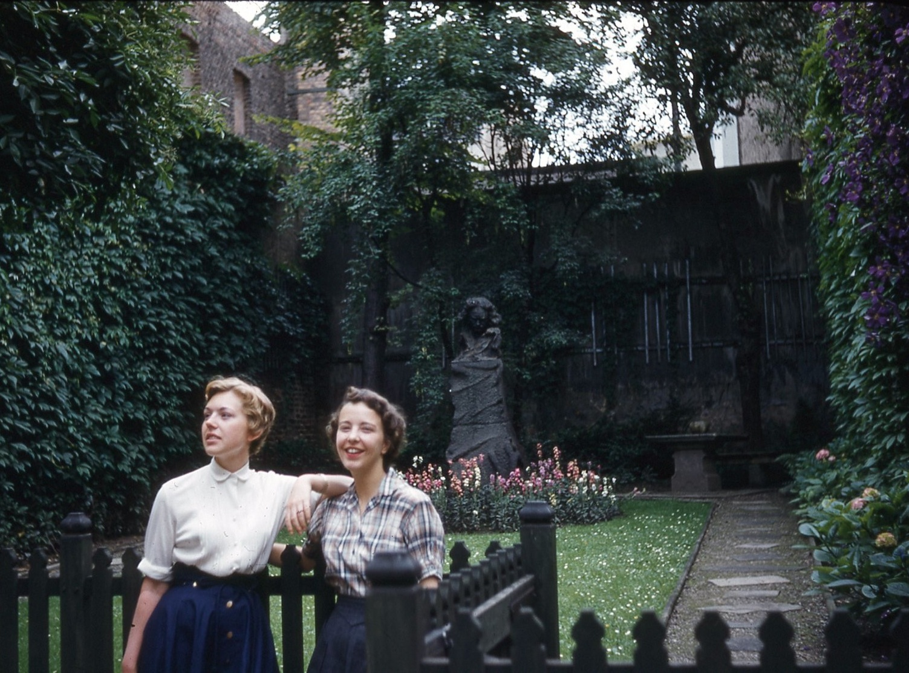
There was the first organ for a church to accompany the choir for his Mass. Displayed are four old Amati violins, cello, his glasses and death mask. Daringly I took a time exposure of a monumental bust of him in the house.
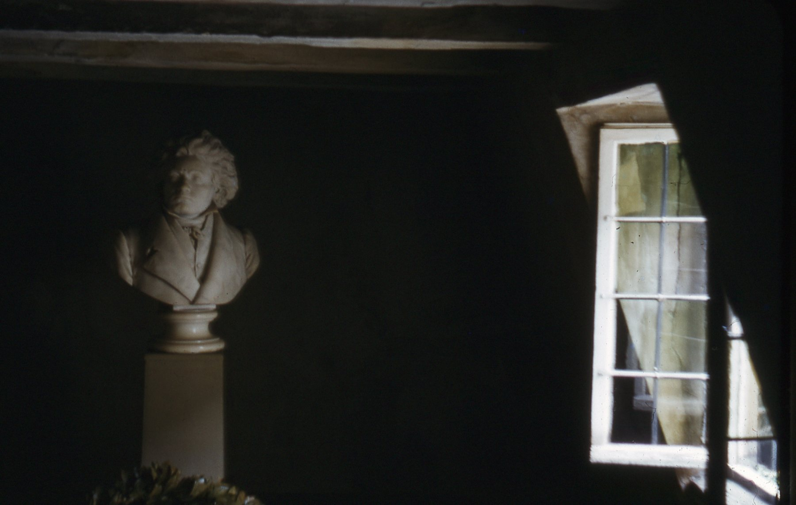

We drove past the University there and at Koblenz got on a boat to take us up the Rhine River. We ate lunch, then went up on the crowded deck and were amazed at what was seen. Beauty beyond belief spread far ahead behind and around us as the boat pushed against the fast tide. The blue sky, clouds, winding waterway, cute little boats, green green mountains and yellow fields swarmed all around. Little villages here and there were dominated by the spires of a lone church, and far above atop a cliff stood a majestic, mystical, exciting castle. Music was played as we turned another bend and caught another breathtaking view. This time it was the rock on which sat the Sirens in The Odyssey. All too soon the three-hour boat ride that I shall never NEVER forget ended and we drove on to Frankfurt.
Corky Lonegren got me to go out with some boy – Henry Van Vleck – from Hartford, Conn. Eight of us went and had beer at the Carnival there, then went riding in the gas bumper cars and had lots of fun. Henry tried but didn’t win me a giraffe at the shooting gallery though.
While having a beer later in a café some German half drunk man stopped to talk and tell us about being a P.O.W. in the U.S. and his women and poor life. Fascinated by Corky, he stayed but finally left and we followed soon after.

Date: Uly 30, 1956 – Monday
Place: Frankfurt – Grand Hotel
Weather: Sunny and nice – warm

Because of a late breakfast I almost missed the tour – and what a tour! Our rather stupid guide began seriously describing the rehabilitation of Germany and Frankfurt (65% was destroyed) and told us Frankfurt is the banking center of Germany. It was sad to see the shelled Opera House, once so famous for its acoustics. We only drove through and around parks, the U.S. Army Headquarters, and saw the very modern American Consulate General and University (1912) and Museum of Natural History. We visited Goethe’s House that is 280 years old. The furniture was stored away during the war. In the music room was a harpsichord with the strings up against the wall. Very unusual! The spinet and old astronomical clock were very interesting plus the ink splattered desk. Some of the paintings were rather weird, too.
The City Hall was a waste of time, but we amused ourselves with the funny felt shoes we had to wear in the Gallery . We crossed the floor slipping and sliding and formed silly processions which received frowns from poor Mr. “B.”
After lunch I did some shopping and stopped to join some of the girls while they finished a beer and then I finally found a charm with Sue’s help.
That night I had a blind date with an ex-roommate of Bette Van Deventer’s date from Scarsdale. Dick McLean from Maryland was very nice – not too cute. We went to a place to hear jazz. It was funny because Bette met us later. She jilted another boy who took four girls along with two other boys who left at 11:45 p.m. to go on duty. How does Bette doe it?! My date did try to show me some romantic spots – an old mansion and park with lake and swans, but distance was held. Had a ride back in a nice white sports car. It was only 2:30 a.m.

Date: July 31, 1956 – Tuesday
Place: To Nuremburg – Furstenhof
Weather: Fair – rain – clearer

En route we stopped to visit Wurzburg Castle, although we complained hard enough. This soon stopped as we entered and first went into the lovely yet very ornate “Garden Hall.” The ceiling was painted by Johann Zirk in 1750. Over the grand staircase is a huge almost three dimensional fresco with figures standing out like statues here and there. The Reception Rooms had much stucco, gorgeous chandeliers, rococo doors with gold leaf, paintings, and mirrors. A beautiful garden was in the back with a small fountain. It is sad that half of it had been destroyed. Being late on schedule, we didn’t have time to stop and wander through Bambery , but did get pictures of the famous bridge between the Bishop’s Town and Burgher’s Town.
Climbing aboard again, we wound through more little towns while playing bridge or reading as we went, finally reaching Nurnberg in time for a late dinner.

- - (favorite of Germany) --
Date: August 1, 1956 – Wednesday
Place: Nurnberg
Weather: fair

In the morning we had a very nice guide show us the charming town. There, there are many Bavarian cathedrals and old quaint typical houses. I caught a quick look at the “Fountain of the Seven Virtues” and wandered a bit through the former Church of the Holy Spirit, now an old people’s home. I was fascinated in the Crucifixion Court with its statues, and again by the rushing water around and under the building.
We stopped but didn’t enter The Church of Our Lady (1390) and inspected the separate bell tower nearby while the clock was striking noon. In the old medieval square of the old city, I saw the house of the painter Olirer and then climbed the short hill past the “Witches House” over the wooden draw bridge, over the deep waterless moat, through the very thick walls to see the “Burg” (Castle) of Nurnberg. The main fortress since 1550 with a great view of the city.
Our guide in a rush left us off a the St. Lawrence Cathedral> Brent Faunce and I almost didn’t go in because we only had 4 cents. It was nice with good wood carvings.
Lunch? Brent and I set out to find a “Bull” – mind you – for the Spanish bus driver “Lucie” because it was his birthday. After much search in and out of store after store, having a terribly funny time trying to explain just what we wanted, we finally found a bull sponge in a baby store. I didn’t quite make it to lunch at the hotel after that. Laugh! I had a bath and talked with Brent. Elaine Thatcher and Linda Vaughn, Julian and Lucie loved the cake – and especially the bull. “Harvey” the rabbit was there also.

Date: August 2, 1956 – Thursday
Place: To Ulm – Bundesbahn Hotel
Weather: fair, sunny, warm

After driving over and through many winding and steep slow hills and eyeing the many “U.S. Forces in Germany” cars and camps along the way, waving friendly-like to all onlookers as we passed, we stopped for lunch and a small tour in Rothenberg – the oldest medieval town in Germany. Nobody, me too, wanted to stay there until we saw what we didn’t want to see. At noon, at the old Consulate Drinking Hall, we watched the town clock strike and the two neighboring windows open, showing two townsmen drinking slowly their beer. Cute. The fountain built in 1608, gets its water from lakes and is pumped in. The old stone fish tanks are still there with cute tales of tradition surrounding them. On some buildings can be seen the eagle of the Holy Roman Empire. The windows fascinated me. They ad been made from bottoms of wine bottles – slanting windows at that.
The Town Hall was built in two styles: Gothic and German Renaissance. It has a fascinating passageway under it with tales of prisoners. Outside the church is an old statue from 1078 and the Nuns’ Home was charming. Old beer mugs, fortified walls, towers, prisons no longer used, proud people, the beautiful view of the valley far below, little houses, mills, rolling fields, a cute artist painting the Fortification Tower, made the “Fairy Tale Town” complete.
After carefully squeezing the big BIG bus through the tiny narrow gateways, we were on our way to Ulm, only turning the wrong way once. The hotel was over a railroad station but not bad. - No men around.

Date: August 3, 1956 – Friday
Place: To Berne - Baren Hotel
Weather: Fair, sunny – warm

Jinx day. It started with our one man “Wilson” oversleeping and making us over a half hour late starting (8:30 +). We drove and drove over and through more and more hills and low mountains catching delightfully wonderful views of countryside, skating through old, almost poor villages with small children playing in the green prosperous fields with animals smiling at the sun. - All fine and dandy. We were madly reading “Fielding” to see what was what and best to do in Switzerland. We had a relatively quick lunch in some tiny town – somehow getting out of veal and having delicious omelette, salad and fruit and free beer – can you STAND it? Yum! How I LOVE German beer (although Tuborg isn’t bad from Denmark)
Soon over the border, another stamp on our Passport – this time acquired by a promised kiss to the officer by two of our girls (Peg Crowther and Mary Hately Quincy). That was funny. We even had to stamp them ourselves. Did we have anything to declare? Hell, no! Let’s get on to Switzerland!
Passing through Zurich and in the open again, we lost the baby bus. While waiting along the roadside, a few of us ran up the steep hill for a look at the other side. It was there. Skip Meeker nearly broke her neck but she did climb a tree and fetched some luscious cherries. Flowers in hand, and the baby bus regained, we sped on our way. We stopped again by the unavoidable flat tire. Oh, woe! - Late dinner again. The beds had better be soft. – They were, after a 9:30 p.m. dinner.
Really - I’m in Switzerland!

Date: August 4, ’56 – Saturday
Place: Berne – Baren Hotel
Weather: Sunny – fair – shower

Excited as I am to be here, I chose to sleep this morning rather than take a short guided tour around the town. It felt SO good, and I hardly did anything until lunch. Veal again – Oh well.
Gathering up energy and my empty purse and camera, I trod off, map in hand. I crossed the cute busy flea market square and wandered past many shops and stores, eyeing the pretty things. Ha! In front of the cathedral I stopped only to watch some very happy people of a wedding party who were not dressed too elegantly, but happy. I got a lovely view of the river – green and shining – and old wonderful rooftops from the rose gardens. It is a sight to see the high hills off in the distance dotted with houses and trees everywhere.
The day was nice and I loved the walk through a winding cobble-stoned residential section, over a bridge to the famous bear pits that cost nothing to see! I gladly got a closer view. On oe side were the big bears, dancing, turning and sitting up and rolling over for a bite to eat. On the other side are the baby bears. Cute? Not too! I pushed myself through the crowd and I laughed along with the rest of them. A scraggly one was the troublemaker which was tumbling and having a great ole time. Such “show” bears!
I walked back along the bank that was covered with green green grass. I crossed the main bridge, went to see the Clock Tower and Prison Tower – not too important. Running back, I didn’t get wet from the slight rain, and slept until dinner, -- and now to bed.
Bill Boyle (Delt at W&L, from Concord, NH) dated Sue. At 12:30 a.m. they came in and woke me. There we were – my hair all up – and he sat on the bed and talked with no lights on. Thank goodness! Very nice. It was such fun to hear about college life again. What’s it like??

Date: August 5, ’56 – Sunday
Place: To Geneva – La Residencea Hotel
Weather: Fair – sunny, warm

We drove from Berne to Lausanne where we welcomed a good lunch in a nice hotel. From its upper terrace we got a fair but misty view of the lake and the hills splashing boldly into it. Grier, Mr. B and I took a short jaunt up and down the steep streets and then all went by bus for a visit guided by a Brooklyn student there. Up on “Signal Mountain” we got a lovely view of the country and even the borderline of France and the Jura Mts. We could see Mont Blanc and, of course, Lac Leman which was exciting.
Even better was the drive around the lake to Geneva. Up, over, and around pre-mountains. Seeing really for the first time the well thought of Swiss chalets – each with its own personality, steps going up to the second floor, cute barn, shed, animals and carved facades. I’m so curious to see what the insides are like. – Someday . . . (dreamer that I am!) The views are absolutely breath-taking and a haven for camera fiends such as me. I get so I frame everything I see now. Ridiculous! But clouds foaming here and there with grey or green peaks jutting up all around, some with snow still on their ragged peaks, and then there are the assurances of peace with the musical clanking of the cow bells down in the rich pastured – a sound wonderful to the ears in the clean fresh air.
The shepherds in their dark flowing cloaks, staffs and funny hats were seen with open mouths while their dogs raced among the keep. Oh, so divine!
Here I am in Geneva over looking lovely Lac Leman. Hooray!

